Lab 27 task 1: Import Update Files to the Image Depot

You import an ESXi image, sample vendor add-ons, and sample test components to the vSphere Lifecycle Manager image depot. You use these images to update the hosts in the ICM-Compute-01 cluster.

1. Using the vSphere Client, log in to sa-vcsa-01.vclass.local by entering administrator@vsphere.local for the user name and VMware1! for the password.

2. From the Menu drop-down menu, select Lifecycle Manager.
The Image Depot page appears in the right pane.

3. Import an ESXi image to the image depot.
a. In the right pane, select Import Updates from the ACTIONS drop-down menu.
The Import Updates dialog box opens.
b. Click BROWSE and navigate to Desktop > Class Materials and Licenses > Downloads.
c. Double-click VMware-ESXi-7.0.0-15847920-depot.zip.
The Import Updates window opens, displaying a progress bar for Step 1 of 2.
After Step 1 completes, the window closes, and the Import updates task appears in the Recent Tasks pane. This task represents Step 2 in the process.
d. Monitor the Recent Tasks pane and wait for the Import updates task to complete.
e. Verify that your uploaded image file appears in the Image Depot pane.
4. Import sample vendor add-ons and components to the image depot.

a. From the ACTIONS drop-down menu, select Import Updates.
b. Click BROWSE and double-click SampleAddonsComponents.zip in C:\Materials\Downloads.
c. Monitor the Recent Tasks pane and wait for the Import updates task to complete.
d. Click VENDOR ADDONS and verify that four items appear in the list.

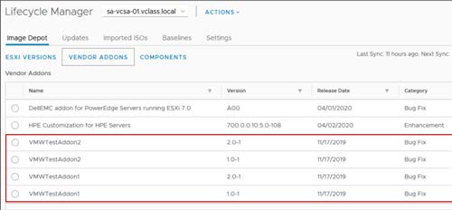

5. Import one more component to the image depot.
a. From the ACTIONS drop-down menu, select Import Updates.
b. Click BROWSE and double-click VMware-ESXi-7.0.0-15847920-vib-test-certs.zip in C:\Materials\Downloads.
c. Monitor the Recent Tasks pane and wait for the Import updates task to complete.
d. Click COMPONENTS and verify that the Test VIB signing certs component and two test components appear in the list.

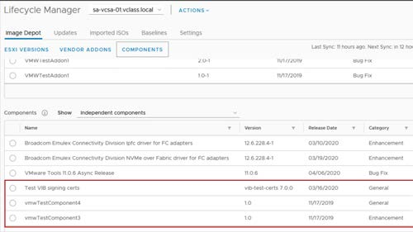

6. View details about the images, add-ons, and components that you uploaded.
a. On the Image Depot tab, click ESXI VERSIONS.
b. Select the ESXi entry in the list and review the details and components that appear to the right.
The ESXi version, release date, category, and a ful list of components are provided.
c. Click VENDOR ADDONS and select the first add-on in the list.
d. Review the details that appear to the right.
The add-on version, release date, category, and a list of added components are provided.
e. Select the other add-ons in the list and review their details to the right.
f. Click COMPONENTS and select the first component on the list.
g. Review the details that appear to the right.
The component version, release date, category, and severity are provided.
h. Select the other components in the list and review their details to the right

